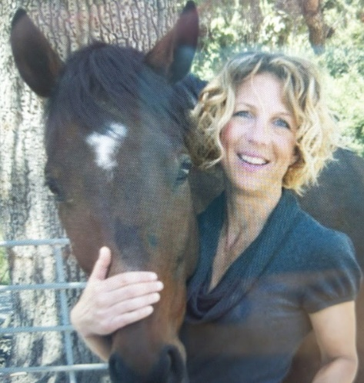

Meet Board Member Lesli Preuss

When did you join the board?
A fellow board member brought SAVE to my attention and asked if I would consider joining. He was asking, I believe, because of my professional experience as a Child Psychologist in addition to bringing some geographical diversity to the Board since I reside in Los Angeles; what Nick didn't know at the time was that I had actually lost a brother to suicide - so I didn't blink an eye. I applied immediately. Then, after speaking with Dan and Patrick and hearing about what SAVE has done and continues to do in the field regarding the education around and prevention of suicide I was thrilled to become a part of such an incredible organization. And I continue to be in awe of all that SAVE does!

Why did you join?
I joined the Board of SAVE in 2021.

What skills do you bring to the board?
I have been a licensed Clinical Child Psychologist for 20 years and have been involved in program development in multiple areas including suicide prevention at the University of Michigan Medical Center. I continue working in private practice and seeing children and adolescents who struggle with many of the issues that SAVE works to address. Moreover, I live in Los Angeles which brings a bit of geographic diversity to the organization. It is my hope that my clinical experience and knowledge, my personal journey with a family member who committed suicide, and some of my connections in the LA and New York City areas will be valuable contributions to the Board.

What do you most like about serving on the board?
The SAVE Board is an incredibly diverse group of intelligent, driven, and well meaning individuals who are truly focused on the mission of the organization and it has been an absolute joy to work with them. I feel inspired by the work that is being done and the camaraderie and respect within the organization. I am growing as a professional and feel like SAVE takes the work in this field to a new level. It is truly an honor to be a part of SAVE!

